Project Title:
Demonstration and Comparative Analysis of API Rate Limiting Algorithms Using AWS Cloud

Team Name:
Team Sentinel

Under The Guidance Of:
Prof. Suhas Joshi

Team Members:

NAME | PRN
Avadhoot Gandhe | 1032232470
Chetanya Jain | 1032232577
Adit Ahuja | 1032232630

Table Of Contents:

Title | Page No.
Problem Statement | 3
Overview | 4
Basic Functionalities | 5
Architectural Diagram | 7
References | 9

Problem Statement:
In modern cloud-based applications, APIs serve as the primary communication layer between clients and backend services, including machine learning models, databases, and business logic. As APIs become publicly accessible, they are exposed to excessive traffic, misuse, brute-force attacks, and denial-of-service scenarios. Without an effective rate limiting mechanism, backend systems may experience performance degradation, service unavailability, and increased operational costs.
Although several API rate limiting algorithms such as Fixed Window, Sliding Window, Token Bucket, and Leaky Bucket exist, most implementations focus on a single algorithm and do not provide a practical way to compare their behavior under real traffic conditions. Furthermore, there is a lack of educational and demonstrative platforms that deploy these algorithms in a real cloud environment and allow dynamic switching between them.
Therefore, the problem addressed in this project is the absence of a unified, cloud-based system that demonstrates, tests, and compares multiple API rate limiting algorithms in real time while protecting a deployed API and model hosted on AWS.

Overview:
This project aims to design and develop a cloud-based API Rate Limiting Demonstration System using AWS infrastructure. The system hosts a backend API and a deployed model on AWS, which is protected by an API rate limiter implemented as a middleware layer. Multiple rate limiting algorithms are implemented within the same system.
A frontend web interface allows users to select a desired rate limiting algorithm and initiate API requests to test the system. Based on the selected algorithm, the rate limiter enforces request limits and either forwards requests to the backend model or blocks them when limits are exceeded. This enables real-time observation of how different algorithms behave under varying request loads.
The project bridges the gap between theoretical understanding and real-world cloud implementation of API rate limiting mechanisms.

Basic Functionalities :

- Implementation of multiple API rate limiting algorithms:
  - Fixed Window Algorithm
  - Sliding Window Algorithm
  - Token Bucket Algorithm
  - Leaky Bucket Algorithm
- Middleware-based rate limiter to intercept all incoming API requests
- Dynamic selection of rate limiting algorithm through frontend UI
- Configuration of request limits (requests per second/minute)
- Identification of clients using IP address or API key
- Real-time request counting and time window management
- Allowing valid requests to reach backend API/model
- Blocking excessive requests and returning HTTP 429 (Too Many Requests)

- Logging of request statistics and rate limit violations
- Display of API responses and rate limit status on frontend

Architecture Diagram :
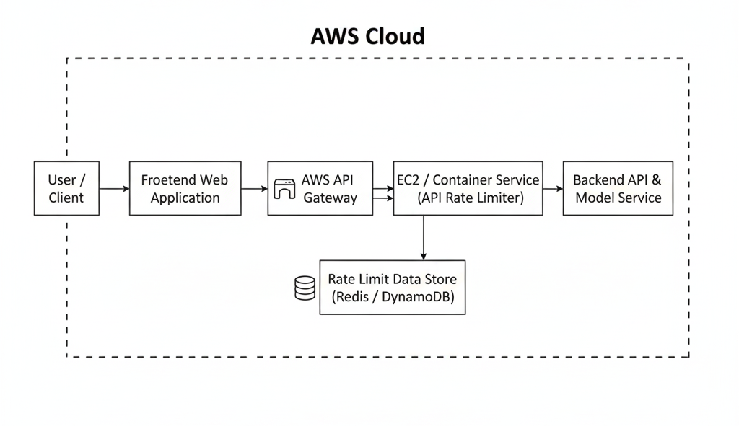

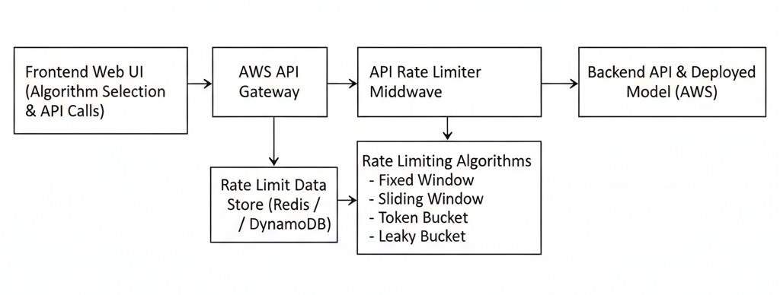

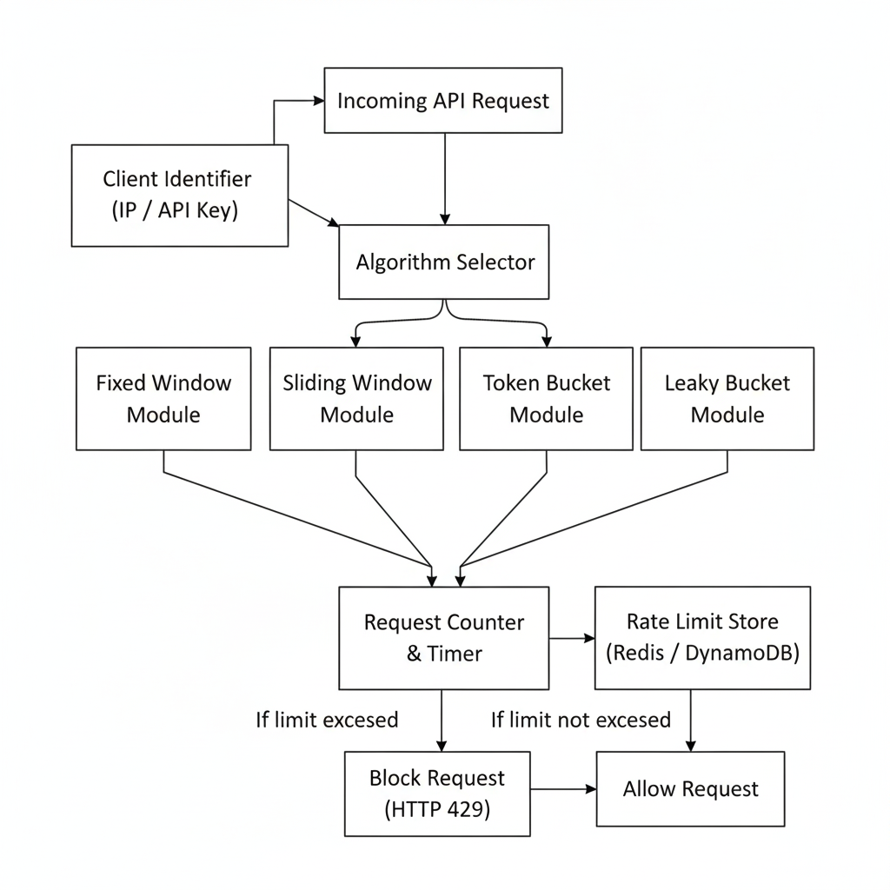

References:
[1] T. Chen and L. Zhang, “Design and Implementation of API Rate Limiting Mechanisms in Cloud Computing,” IEEE Access, vol. 8, pp. 145321–145330, 2020.
[2] M. Villamizar, O. Garcés, and L. Ochoa, “Infrastructure Cost Comparison of API Management Solutions in Cloud Environments,” IEEE Internet Computing, vol. 24, no. 3, pp. 50–59, May–June 2020.
[3] A. Verma and S. Kaushal, “Efficient Request Throttling Techniques for RESTful APIs,” in Proceedings of the IEEE International Conference on Cloud Computing, San Francisco, CA, USA, 2019, pp. 210–217.
[4] Amazon Web Services, “Amazon API Gateway Developer Guide,” AWS Documentation, 2023. [Online]. Available: https://docs.aws.amazon.com/apigateway
[5] S. Newman, Building Microservices: Designing Fine-Grained Systems, 2nd ed. Sebastopol, CA, USA: O’Reilly Media, 2021.
[6] J. Kleinberg and É. Tardos, “Algorithm Design for Resource Allocation and Traffic Control,” IEEE Transactions on Networking, vol. 27, no. 4, pp. 1623–1635, Aug. 2019.
[7] R. Fielding, “Architectural Styles and the Design of Network-Based Software Architectures,” Ph.D. dissertation, Dept. Comput. Sci., Univ. of California, Irvine, CA, USA, 2000.
[8] K. Hightower, B. Burns, and J. Beda, Kubernetes: Up and Running, 3rd ed. Sebastopol, CA, USA: O’Reilly Media, 2022.
[9] N. Naik, “Security Aspects of API Gateways in Cloud-Based Systems,” IEEE Security & Privacy, vol. 18, no. 2, pp. 72–76, Mar.–Apr. 2020.

